Member info 20w23

Dear member!
We are in a continued dialogue around the notification and understand that there is a great concern in your workplaces around everything that is happening right now. We have to wait to send out the next member letter until we have everything as clear as possible at present, given that it is easy to get the wrong information giving false rumors etc.
We now have the notification process and the steps forward until the new notification date of September 30 regarding notice of termination.
In all this, we have also negotiated a voluntary package, where units that become more affected by the notification can be given this opportunity.
Talk to your boss about what applies to your area and you? We have developed this package precisely to give members the opportunity to make a voluntary choice themselves during the notification process. This choice of voluntary package is available until July 8 to choose. After that comes a holiday and after the holidays during week 33-34, we at Ledarna are informed about which members who have no place in their home organization and where it can be matched locally and centrally to the positions of other units.

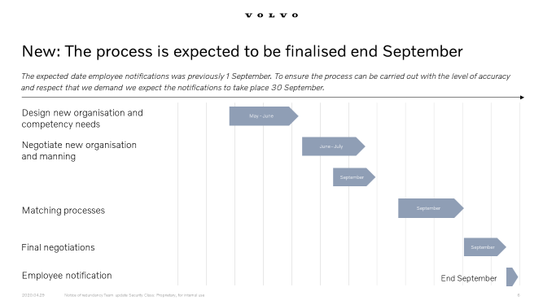

As far as continued layoffs and short-term work are concerned, this will continue as work around until July.
Update your CV and People Profile
We recommend everyone now to update their resume and their People Profile page. This is so that in the upcoming matching process after the holidays we look at each member who becomes redundant from their own local unit, so that they can then be matched centrally to the company.

No added 5th holiday week!
We have also been informed that there is a worry that the company wants to spend even the 5th holiday week in connection with this year's holiday (week 33) based on the layoff and notice situation. This will not happen from the company.

Once again in these times, do you keep track of your UIF (Unemployment Insurance Fund) during these times?
Your membership in the union Ledarna does not mean that you are automatically connected to the Ledarnas UIF!
You can also join another approved UIF.
Keep in mind that you must belong to an UIF to have full effect on your income loss insurance.
And that you must report a change in income as soon as possible if you exceed a salary of more than SEK 80,000 / month to Bliwa in order to receive the right compensation in case of unemployment.Read more about income insurance here. (page in Swedish)
The safest way to not miss any payment is to notify automatic payment service or E-invoice. (page in Swedish)
General information about Ledarna in English

If you have any questions or would like to talk, contact one of us three below!
Sincerly

Peter Storm Dan Lidesköld Leonel Diniz
Chairman Vice Chairman Commisioner
0708-20 90 36 0723-717847 0733-332736
peter.storm@volvocars.com dan.lideskold.sr@volvocars.com leonel.diniz@volvocars.com

