Member info 21w08

Dear member!
Here is a new membership letter.

Salary review 2020-22
In brief, we have negotiated the following:
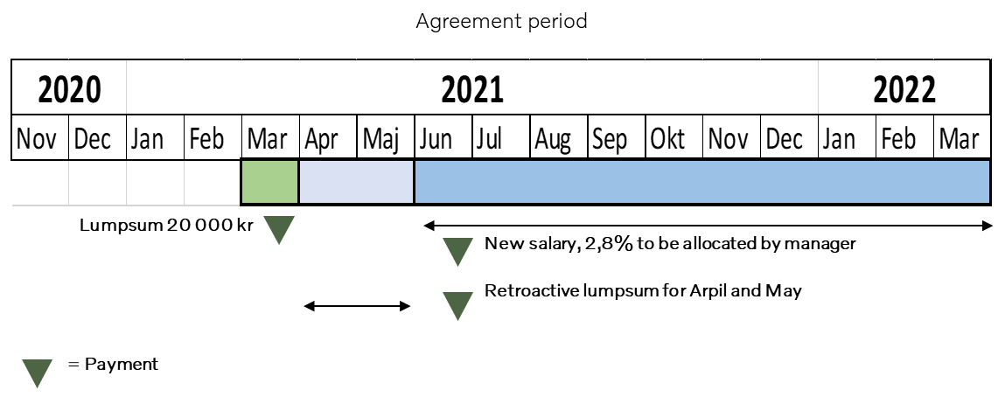
As you know, a central agreement was concluded in October 2020 for the period 1/11 2020 to 31/3 2023. The agreement consisted of two periods, the first of which had a 2.8% increase and the second a 2.2% increase.
Together with the company, we have now reached an agreement that applies to the first agreement period.
- Everyone who was employed on 1/11 2020 is covered by the agreement. However, you must be employed at the salary payment times
- The salary review is based on your performance for both 2019 and 2020
- During March, the salary process will start up in the traditional way with a pot of 2.8% to the salary setting manager. Pay talks 1 take place sometime in March//April and a pay call 2 in May//June. What you get in salary increases will vary individually. Premiums are made based on performance and salary situation
The result of the negotiations was:
- A lump sum of SEK 20,000 is paid with the March salary. This amount is compensation for the period 1/11-2020 to 31/3-2021
- Your new salary will apply from June 2021
- Retroactive salary for April and May, paid as a lump sum and based on your salary premium in June
Other important parts of the new agreement:
- Salary setting manager will receive the full percentage of 2.8% to his salary setting, i.e. no pots of any kind
- In communication to the salary setting manager, will show that the boxes with their limits, should be seen as an indication of what the competition outside the company is right now. It is permissible to set salaries that are outside the upper limit of the boxers
- That if there is a need to adjust the salary by 10% or more, this must be assessed on a case-by-case basis and then you may have to go outside the audit to carry out this
- Monthly provision to the local Volvo pension has been increased to 575:-
- The provision for flex pension/part-time pension has been extended by 0.4% from 1 November 2020, your total provision is now up to 1.7% every month
It has been tough negotiations and we did not get as far as we had hoped. We did not go beyond the central agreement on the level going forward. However, there is some upside to the lump sum (retroactivity) paid in March.

If you have questions or want to talk, contact one of us three below!
With Kind Regards

Peter Storm, Leonel Diniz Sten Henricsson
Chairman Vice Chairman Member (Treasurer)
0708-20 90 36 0733-332736 0729-774864
peter.storm@volvocars.com leonel.diniz@volvocars.com sten.henricsson@volvocars.com

