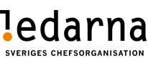
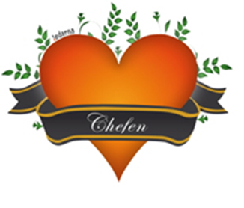

Member info 21w25

Dear member!
Here is a new membership letter

From a trade union perspective, it has been a little calmer after the notice this autumn. In the salary revision in 2021, which we at Ledarna did well in, there has been a bit more dialogue around the strengthened salary talks. We at Ledarna always recommend taking these meetings when you do not feel in agreement with your manager about the process and then start a good process in the continued work that you have progressed together. We feel that there is far too little focus on the soft issues such as salary and skills development in CA&F (one to one) meetings, more focus on deliveries than the person behind.

In addition to this, the company has also taken the step of bringing us back to the workplace as the new normal. At the time of writing, it looks like approx. 25% are in the workplace at present per day. It is important that you and your manager have a good consensus on this to see what is best for you and for your deliveries.

Salary revision 2022 and onwards.
We have continued the local negotiations with the company around a new salary process and what it should look like in the future. We are looking at new conditions and where in the long run there may be a couple of "pilot units" to test the thoughts of a new process. We will return when we have more details of what the new payroll process will look like and also whether there is a possibility to simultaneously change the payroll process for the 2022 audit or if we proceed with two processes to learn in the long run?

CA&F ”Continues Alignment & Feedback”
How does the rollout go on your own unit around the Continues Alignment & Feedback tool. This digital tool will help the manager and employee in the daily dialogue on hard and soft issues. You are welcome to give us feedback on Ledarna how the tool is experienced and how this works on your unit with CA&F?

Do not forget to review your personal page on Ledarna centrally
The information is available at http://www.ledarna.se under "My pages" to be able to change and update there. This is important now when the deduction of 25 Skr for the local club fee is handled centrally
We from Ledarna would like to wish you all a wonderful midsummer and that you get some time of your own for the upcoming holiday that we have all deserved after a very special year of work that we have never been to before.
Om ni har frågor eller vill prata så kontakta någon av oss tre nedan!

with Best Regards

Peter Storm Leonel Diniz Sten Henricsson
Chairman Vice Chairman Commissioner (Treasury)
0708-20 90 36 0733-332736 0729-774864
peter.storm@volvocars.com leonel.diniz@volvocars.com sten.henricsson@volvocars.com

