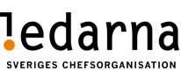
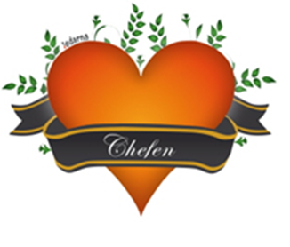

Membership info 23w26

Best member!
Here comes a new member letter.

Salary negotiations finalized for 2023-2024.
We have agreed with the company on a new wage revision agreement that spans 2 years for 2023 and 2024. What has been difficult is to make a good and fair wage revision for 2023 with a notice that is like a wet blanket over us. Therefore, among other things, we have taken the following decision for a simplified solution for 2023.

2023:
A lump sum paid in connection with the July 2023 salary based on 3.9% of the monthly salary based on 12 months between the period 1/4-23 to 31/3-24.
This then becomes 3.9% x the monthly salary x 12.
(Example: 3,9% x 45000:-/salary x 12 = 21060:-)

2024:
The negotiated percentage for 2024 was 7.6% and will apply from 1/4-24 and which is based on the performance for the years 2022 & 2023 with a differentiated salary revision as usual. The salary talk should start around Januari 2024.

VFF the pension will be increased by SEK 76/month from 2024. Total to 702:- from 2024.

Health care allowance will be increased by SEK 1,000/year from 2024, and now ends up at SEK 3,500/year.

The notice.
The process will take place in the following steps:

- Until the holidays, the new organizations must be negotiated.
- Work on matching employees in the new organization will begin before the holidays.
- After the holiday, matching will continue, and redundancy will be determined.
- In September/October, all employees will be notified of what applies, remain in the same role, relocated, or dismissed.

If you have questions or want to talk, contact one of the three of us below!

Sincerely
Peter Storm Leonel Diniz Sten Henricsson
Chairman Vice Chairman Treasurer
0708-20 90 36 0733-33 27 36 0729-77 48 64
peter.storm@volvocars.com leonel.diniz@volvocars.com sten.henricsson@volvocars.com

